**Create Agentic RAG in Lyzr:**

Create new knowledge base using “Create New” button and upload the required website documents:

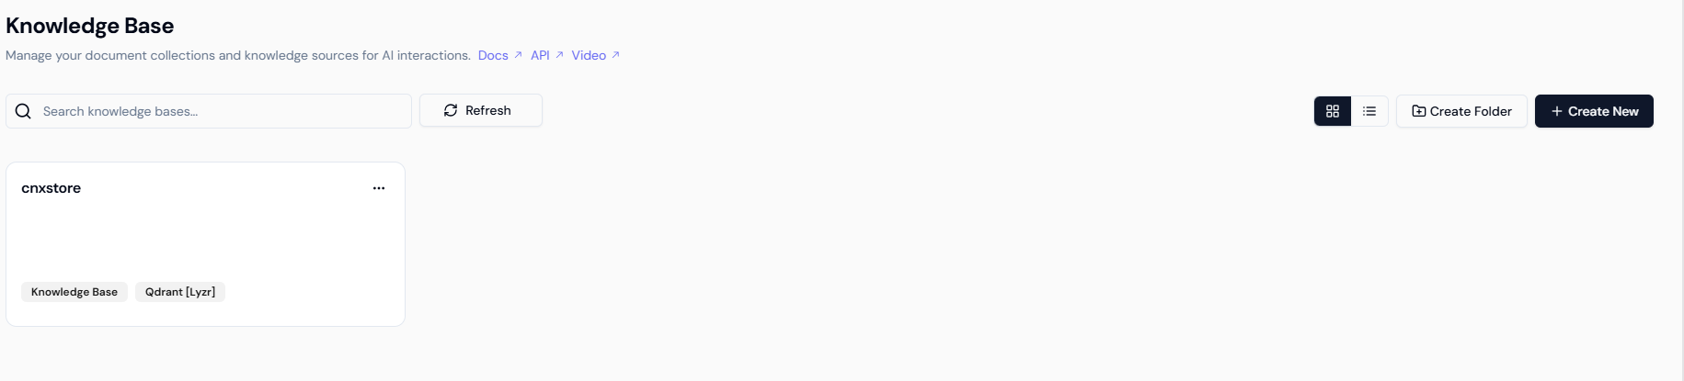

Select newly created Knowledge Base in Agentic RAG.

Also select and configure, Memory option and others as required:

